**Ex : 16 Temperature Monitoring Using Arduino**

**Aim:**

To Simulate a temperature monitoring system using Arduino in Tinkercad

**Components required**

1, Arduino

2. TMP Sensor

3. Breadboard

**Code**

int temp = 0;

void setup()

{

pinMode(A0, INPUT);

Serial.begin(9600);

}

void loop()

{

temp = analogRead(A0);

Serial.println(temp);

1 - (20 + map(0, 0, 1023, -40, 125));

delay(10); // Delay a little bit to improve simulation performance

}

**Circuit**

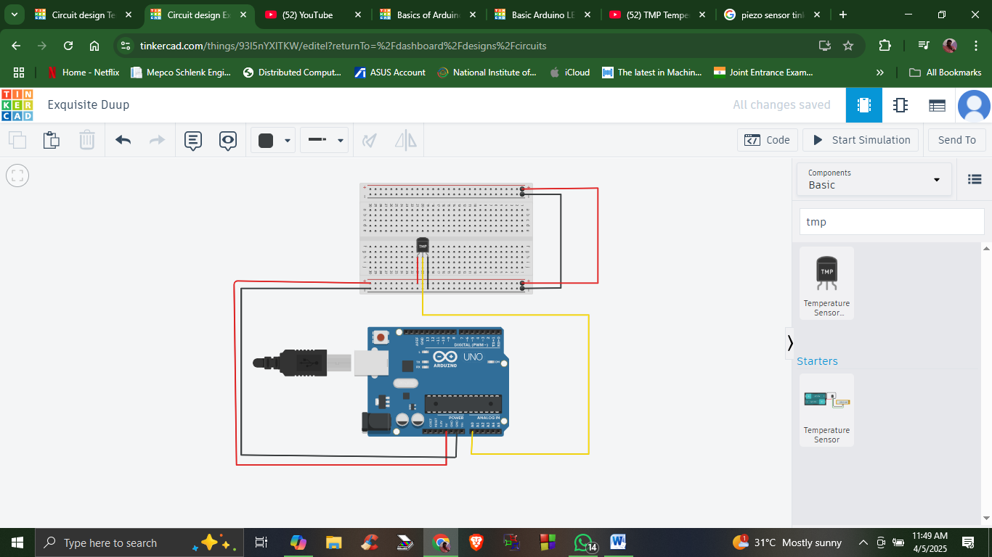

**Output**

Click on Start Simulation

Click on the temperature Sensor

The temperature variations can be observed in the Serial Monitor as shown in the below figure

